Assignment -16
Task 1 – Student Information System Schema
Task:
Design a database schema for a Student Information System and
generate queries using AI.
Instructions:
• Tables: Students, Courses, Enrollments.
• Define primary keys, foreign keys, and relationships.
• Generate queries:
o Insert a new student record.
o Fetch all courses enrolled by a student.
o Count number of students in each course.
Expected Output:
• SQL CREATE TABLE statements and queries for student–course
relationships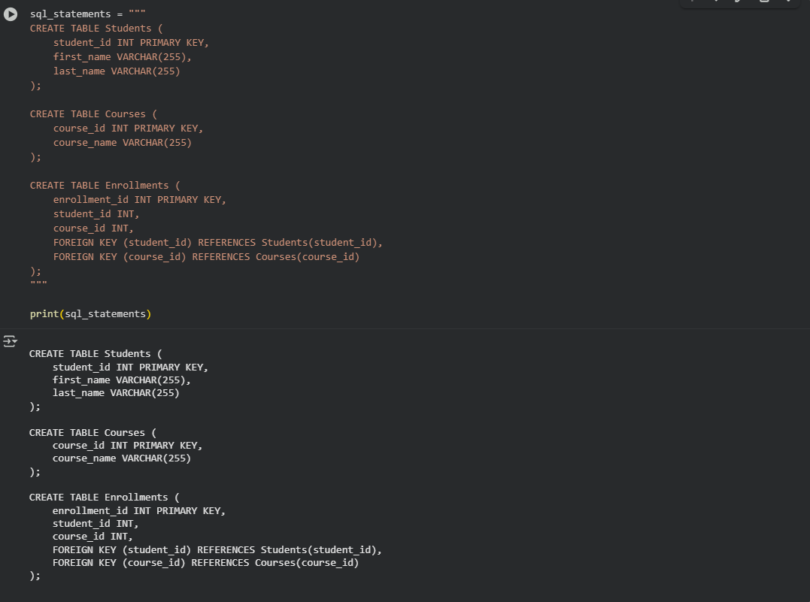
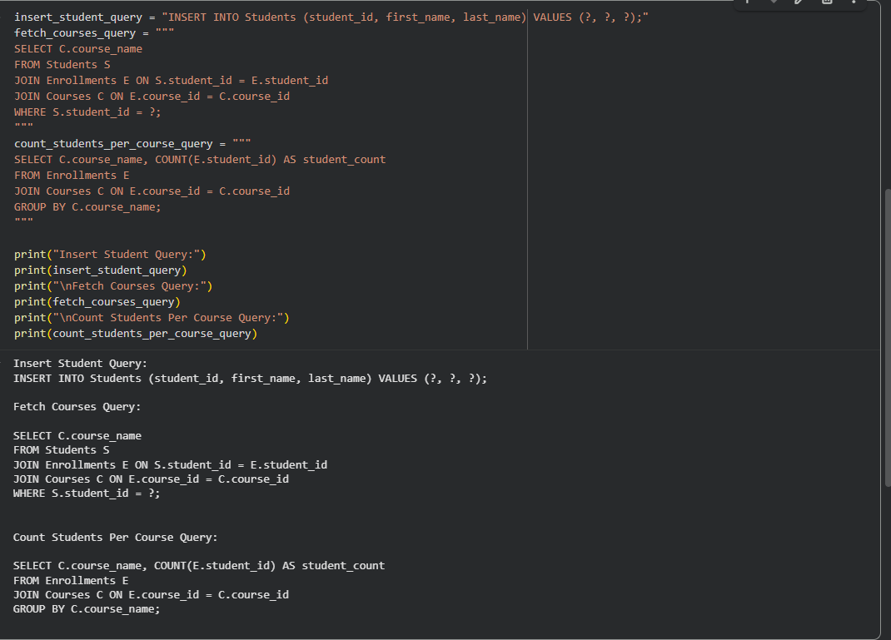
Observation : I have Observed that google colab that The queries allow inserting student data and fetching courses a student is enrolled in, and counting students per course.
Prompt : Design a database schema for a Student Information System and
generate queries using AI.Instructions:Tables: Students, Courses, Enrollments. Define primary keys, foreign keys, and relationships. Generate queries:Insert a new student record.Fetch all courses enrolled by a student.Count number of students in each course.

Task 2 – Hospital Management Database
Task:
Create schema and queries for a Hospital Management System.
Instructions:
• Tables: Doctors, Patients, Appointments.
• Use AI to define constraints (unique IDs, valid dates).
• Generate queries:
o List all appointments for a specific doctor.
o Retrieve patient history by patient ID.
o Count total patients treated by each doctor.
Expected Output:
• Normalized schema and SQL queries with joins
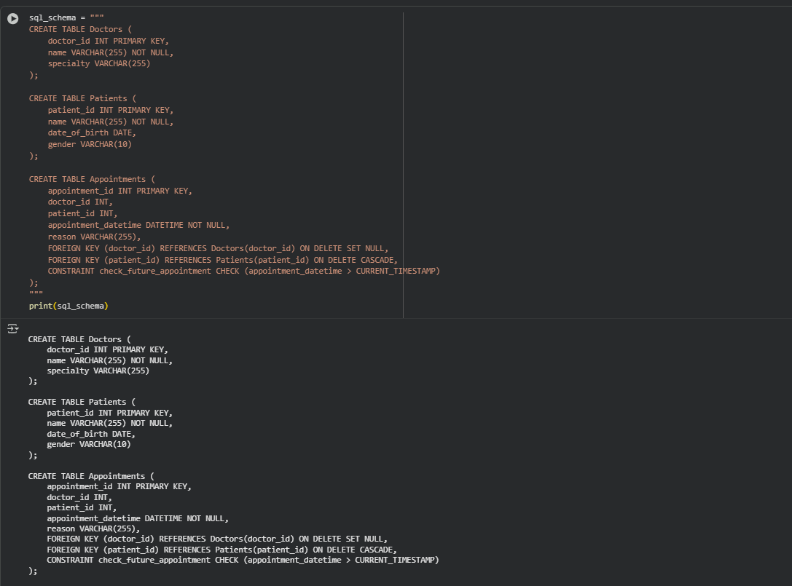

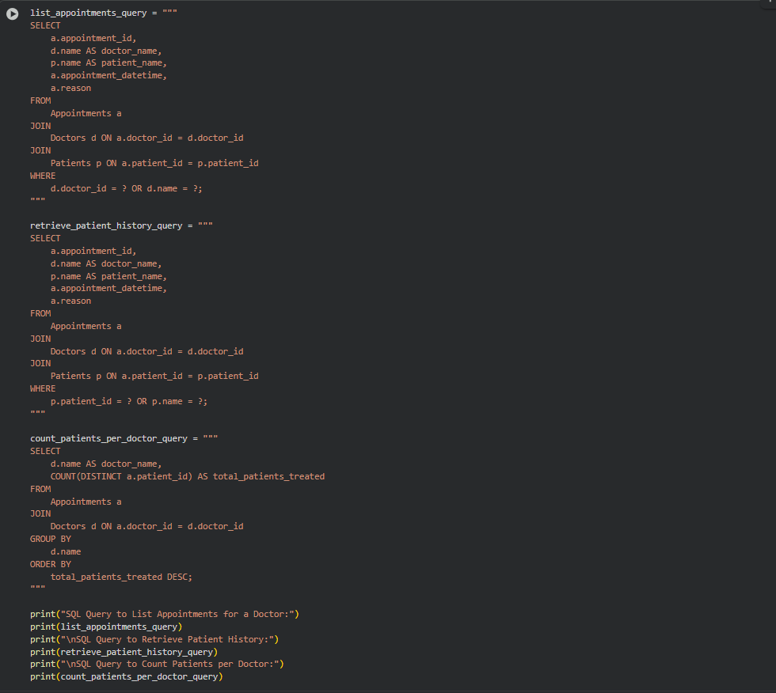
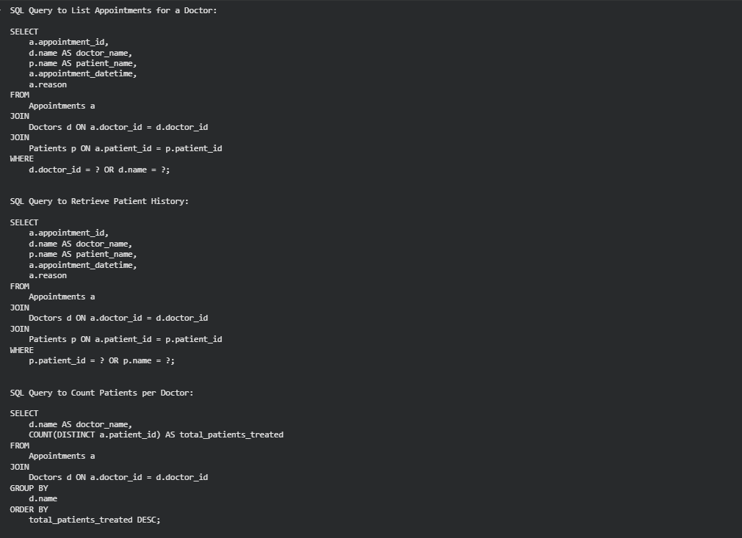
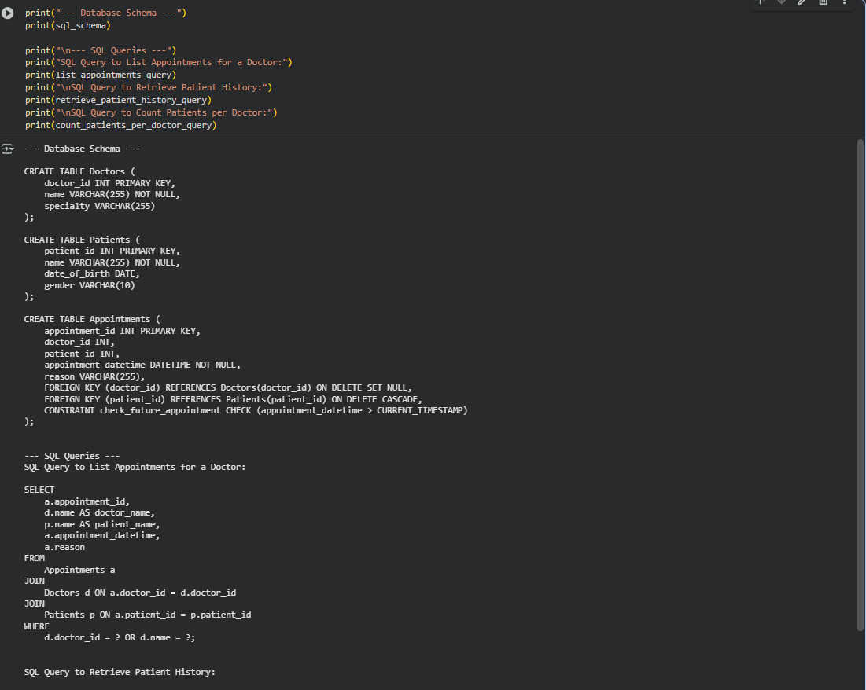
Observattion: I have Observed that the queries effectively use JOIN clauses to combine information from multiple tables, demonstrating how to retrieve related data in a relational database. They also use WHERE clauses to filter results and GROUP BY with an aggregate function to summarize data.

ask 3 – Library Database
Task:
Design schema for a Library Management System.
Instructions:
• Tables: Books, Members, Loans.
• Use AI to suggest indexing strategy for faster queries.
• Generate queries:
o Retrieve all books currently issued.
o Find overdue books (loan date > 30 days).
o Count number of books loaned by each member.
Expected Output:
• Schema + SQL queries demonstrating joins and conditions
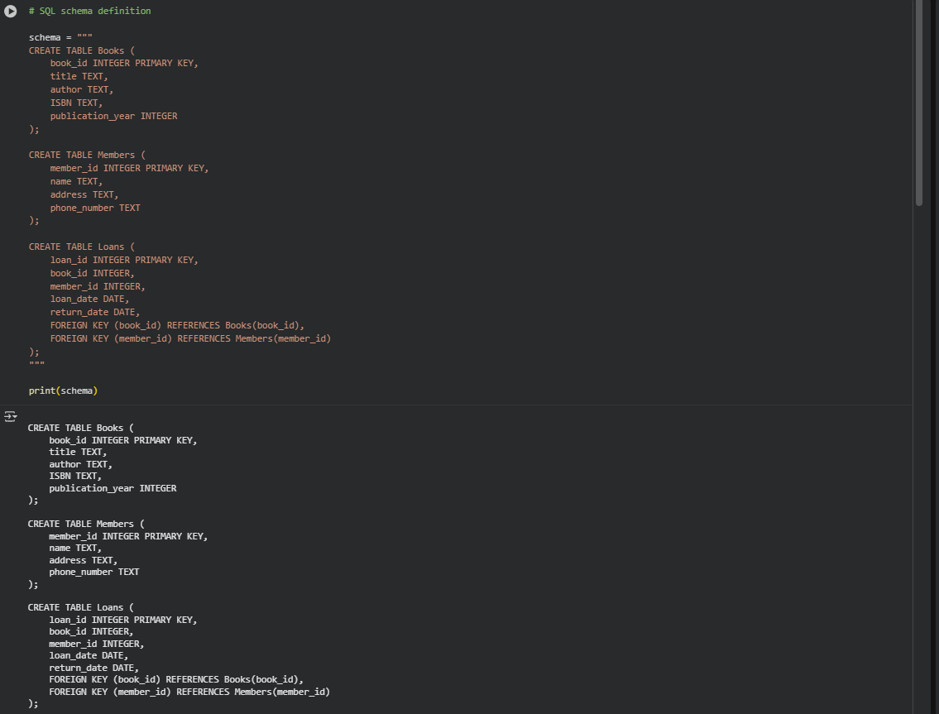
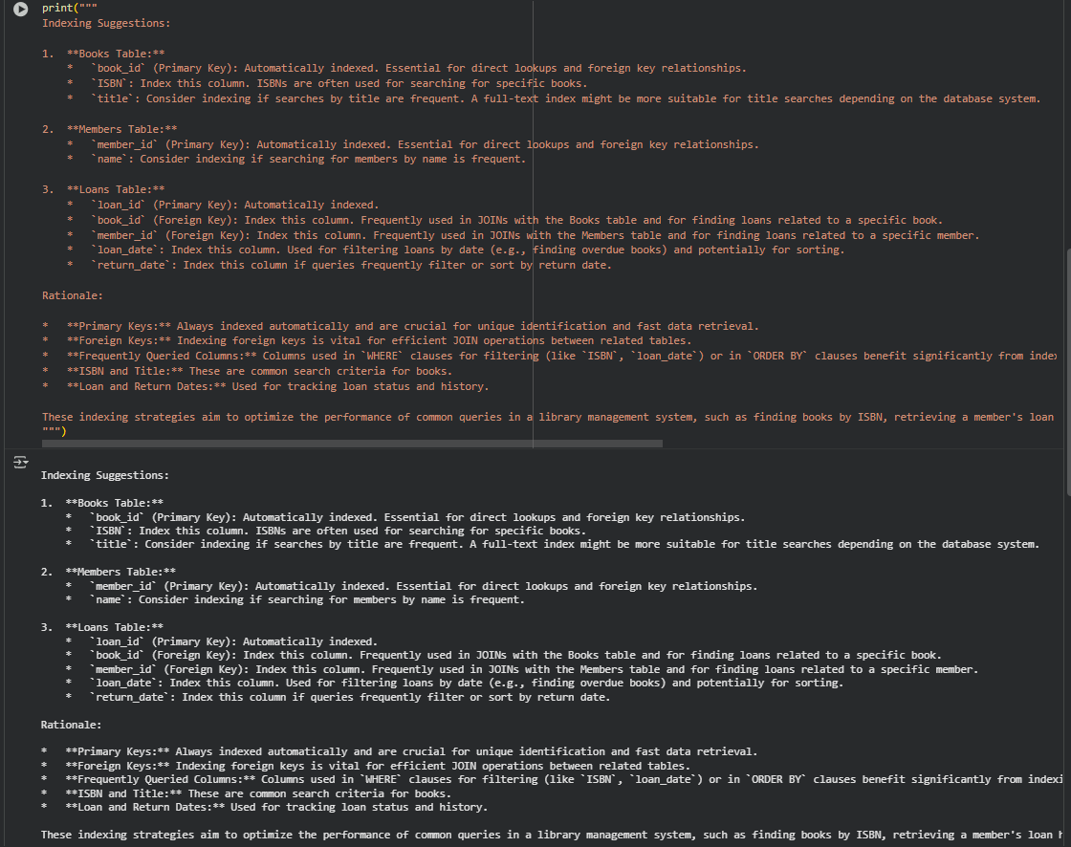
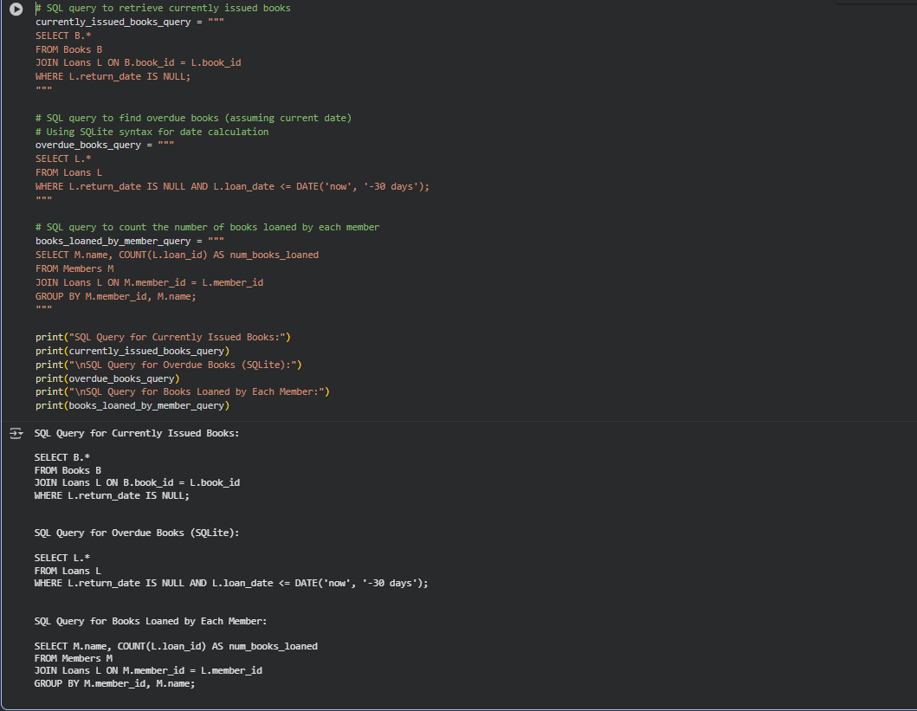
Observation : I have observed that The schema seems well-structured for a basic library system, covering essential entities like books, members, and loans with clear relationships

Task 4 – Real-Time Application: Online Shopping Database
Scenario:
Design a database for an E-commerce platform.
Requirements:
• Tables: Users, Products, Orders, OrderDetails.
• Generate queries to:
o Retrieve all orders by a user.
o Find the most purchased product.
o Calculate total revenue in a given month.
• AI should also suggest normalization improvements and query
optimization.
Expected Output:
• Complete schema with relationships + SQL queries for analytics.
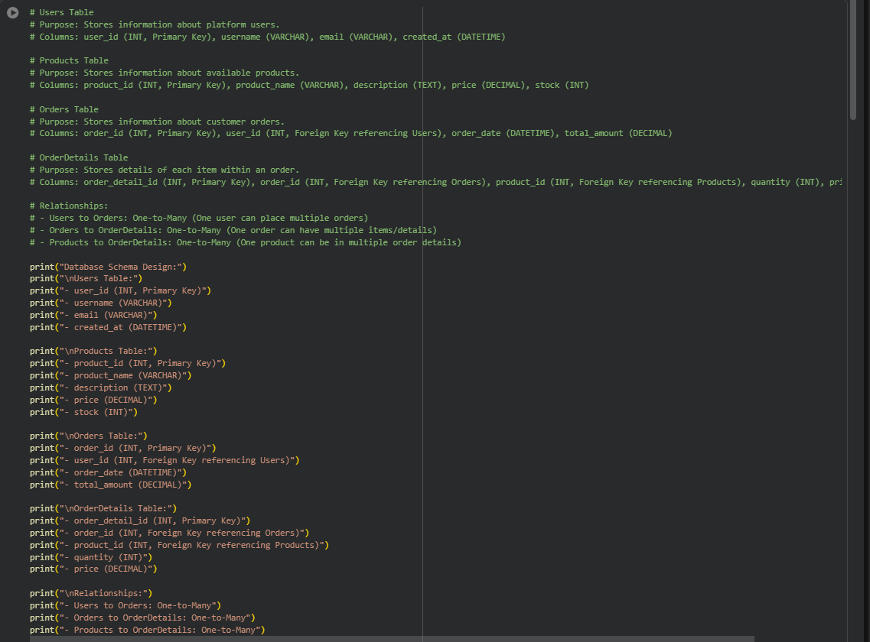
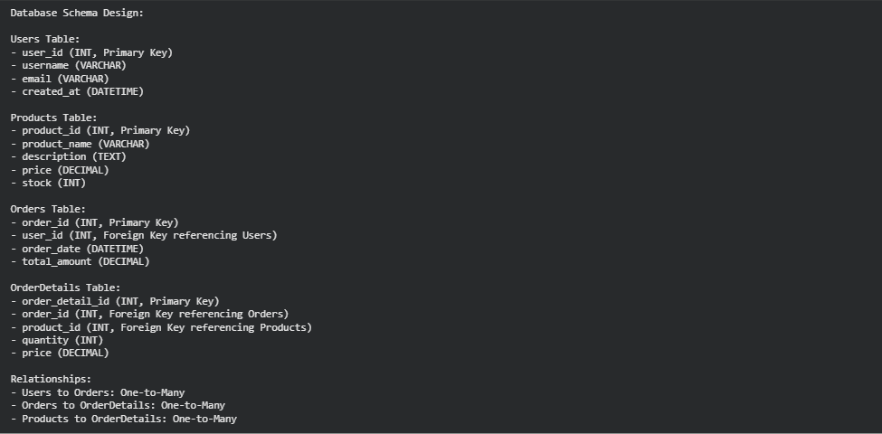

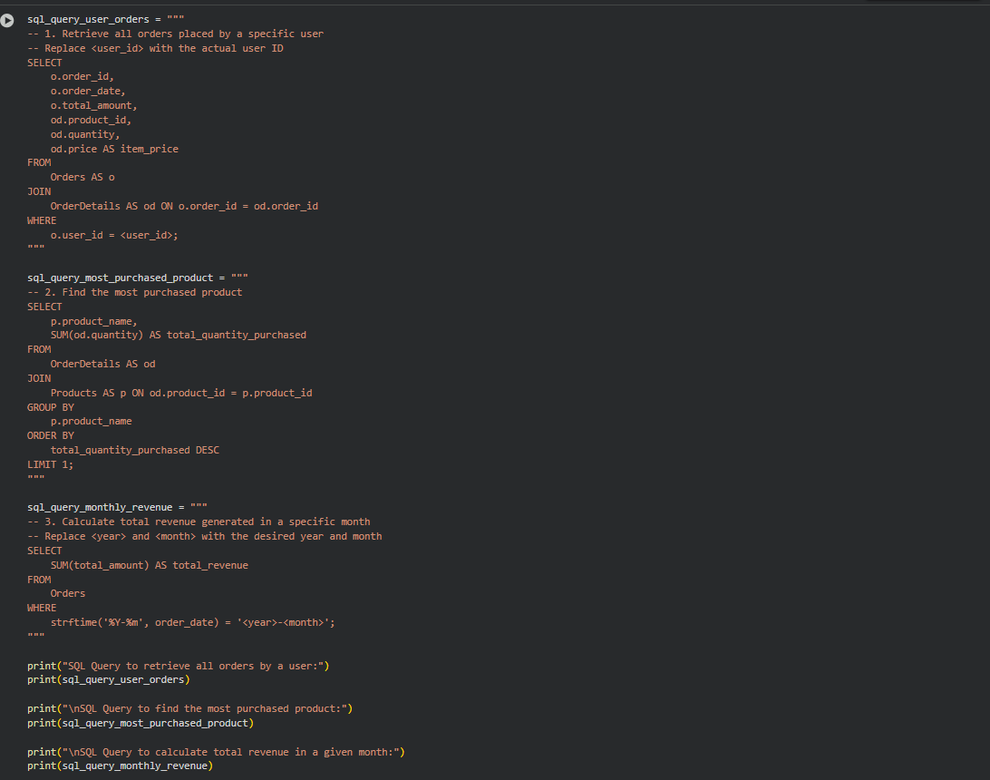

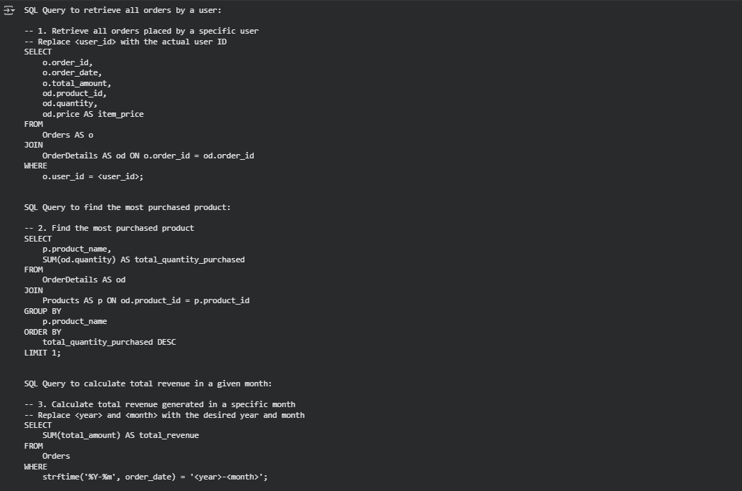

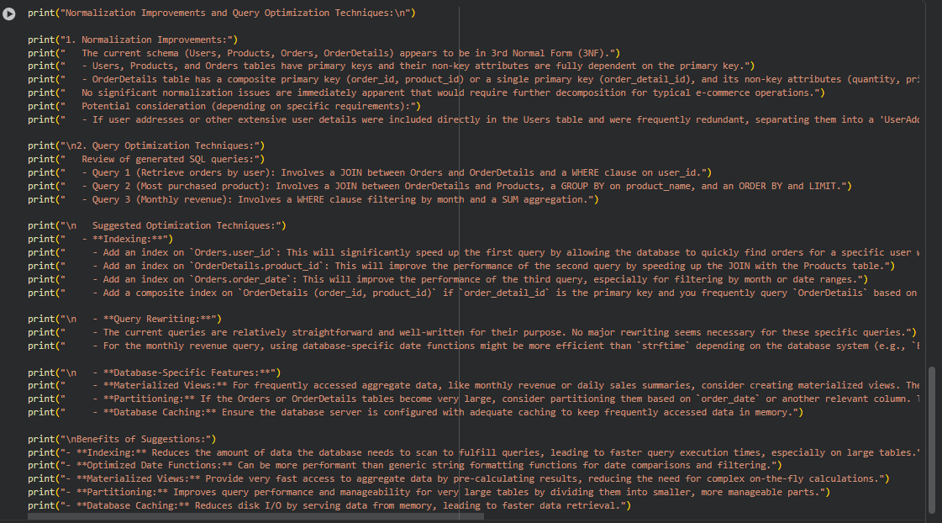
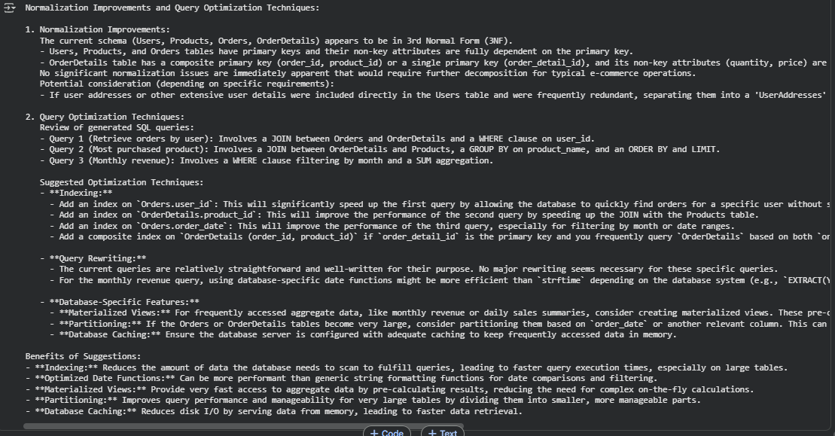
Observation : I have Observed that this is essential for understanding how online platforms manage information. It also introduces important practical aspects like optimizing queries for better performance.

